NAME: B.VEERA SIVA REDDY

REG.NO: 192211938

SERIAL NO: 07

COURSE NAME: FUNDAMENTALS OF

COMPUTING

COURSE CODE: CSA5779

SLOT NAME:D

EXPERIMENT: 1

EXPERIMENT NAME: GENERATION OF NUMBER SERIES

PROGRAM:

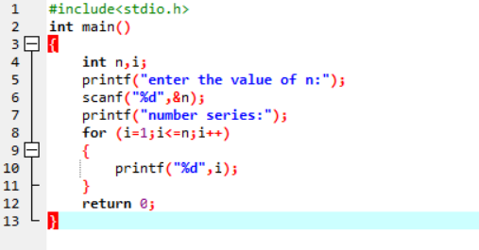

OUTPUT:

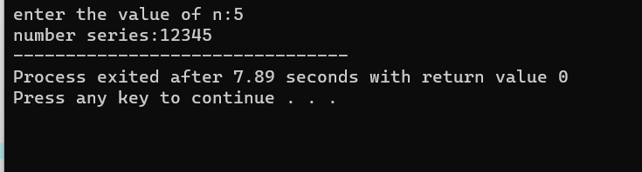

EXPERIMENT: 2

EXPERIMENT NAME: GENERATION OF EVEN NUMBERS

PROGRAM:

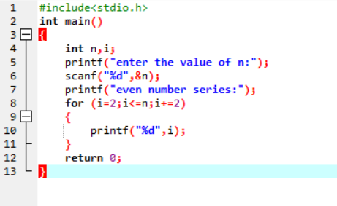

OUTPUT:

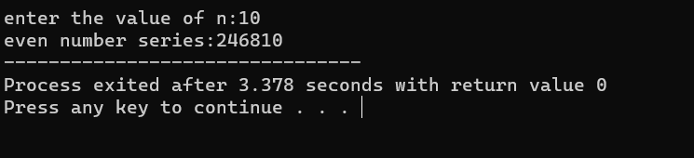

EXPERIMENT:3

EXPERIMENT NAME: GENERATION OF ODD NUMBER SERIES

PROGRAM:

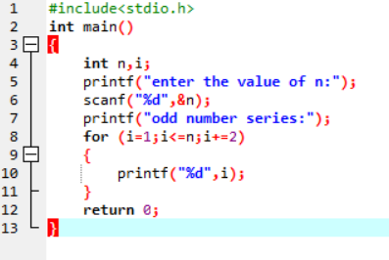

OUTPUT

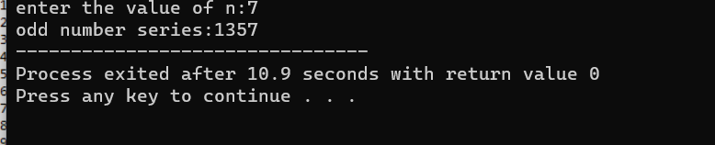

EXPERIMENT:4

EXPERIMENT NAME: GENERATION OF FIBONACCI SERIES

PROGRAM:

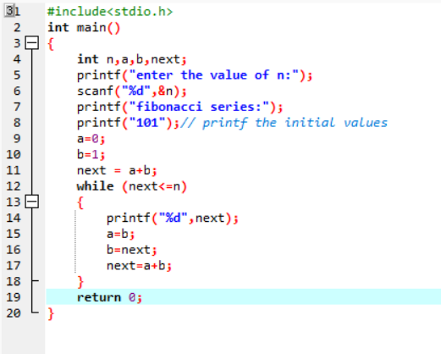

OUTPUT:

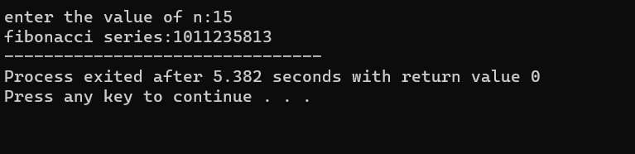

EXPERIMENT:5

EXPERIMENT NAME: SUMMING OF SERIES

PROGRAM:

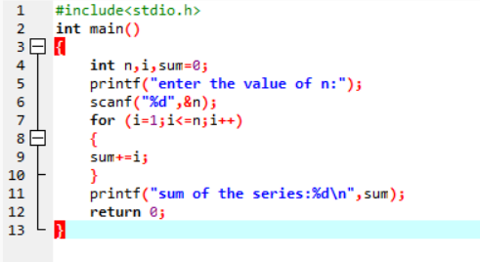

OUTPUT:

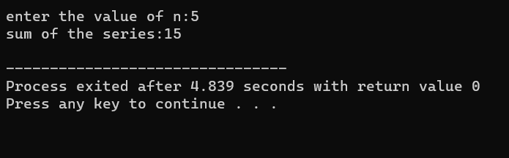

EXPERIMENT:6

EXPERIMENT NAME: SUMMING UP EVEN NUMBER SERIES

PROGRAM:

S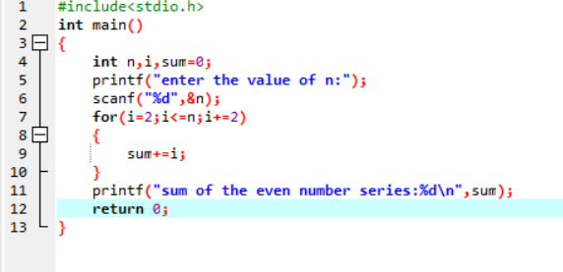

OUTPUT:

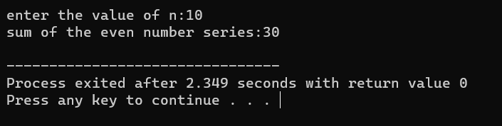

EXPERIMENT:7

EXPERIMENT NAME: SUMMING UP ODD NUMBER SERIES

PROGRAM:

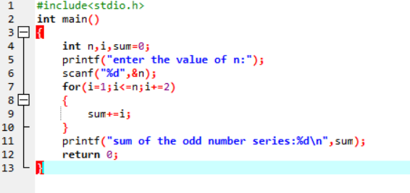

OUTPUT:

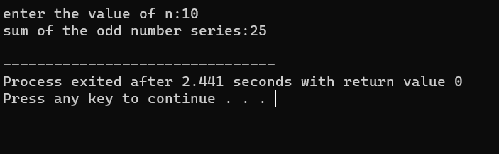

EXPERIMENT:8

EXPERIMENT NAME: SUMMING UP 1-2+3-4+5 ….. N

PROGRAM:

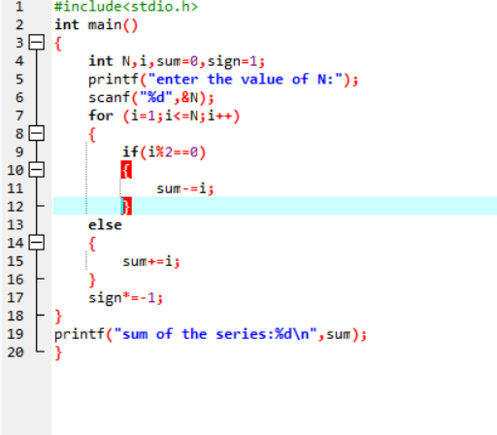

OUTPUT:

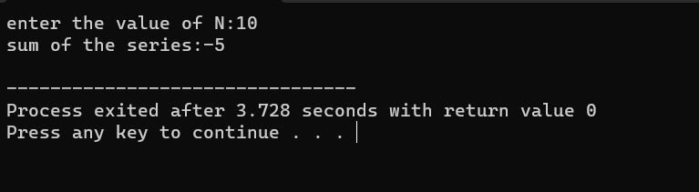

EXPERIMENT:9

EXPERIMENT NAME: SUMMING UP SQUARES OF NUMBERS

PROGRAM:

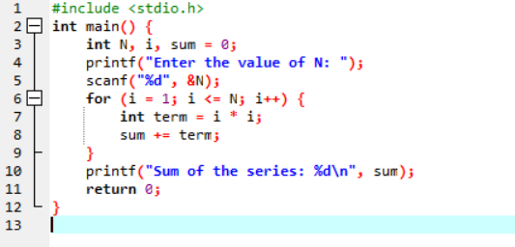

OUTPUT:

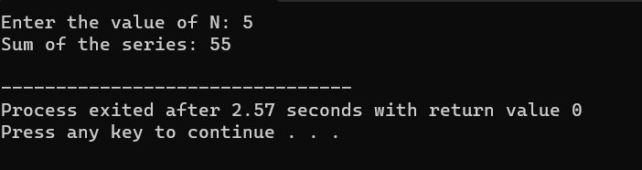

EXPERIMENT:10

EXPERIMENT NAME: SQUARES OF EVEN NUMBERS

PROGRAM:

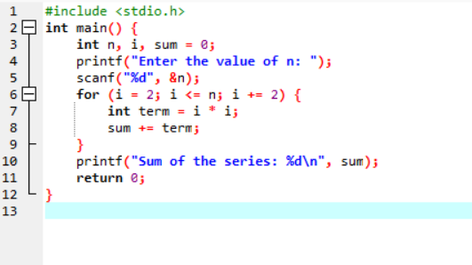

OUTPUT:

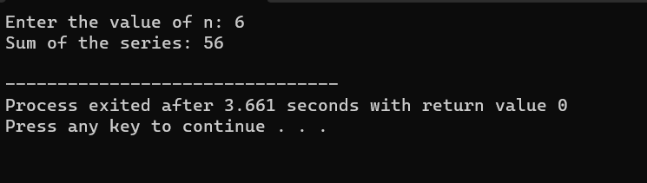

EXPERIMENT:11

EXPERIMENT NAME: Summing up 11+22+33+44+ …. nn

PROGRAM:

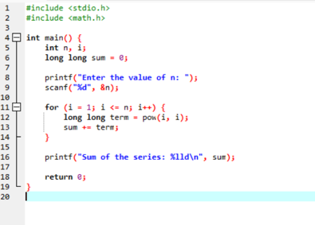

OUTPUT:

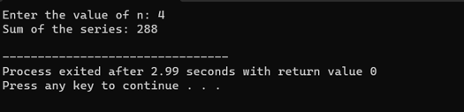

EXPERIMENT:12

EXPERIMENT NAME: Summing up squares of Odd numbers

PROGRAM:

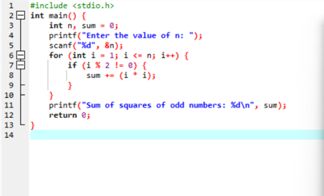

OUTPUT:

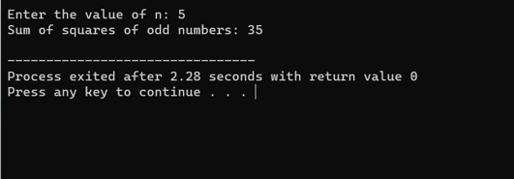

EXPERIMENT:13

EXPERIMENT NAME: Summing up cubes of n numbers

PROGRAM:

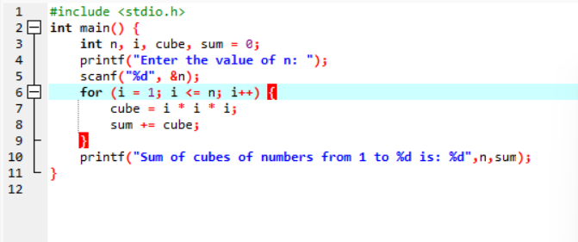

OUTPUT:

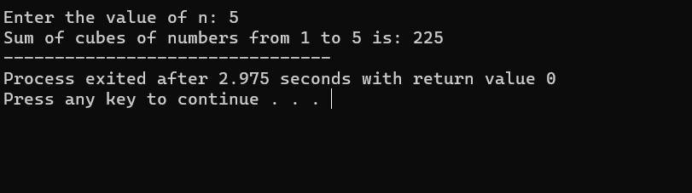

EXPERIMENT: 14

EXPERIMENT NAME: Product series (Factorial of a given number)

PROGRAM:

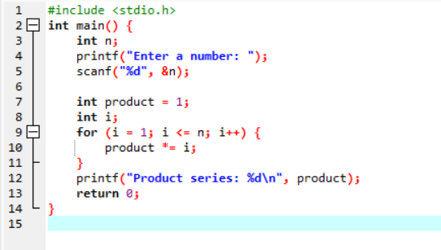

OUTPUT:

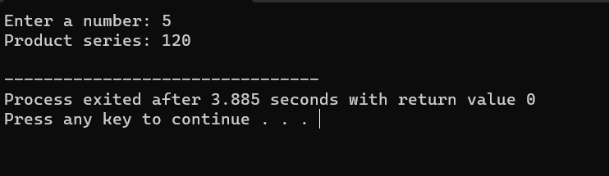

EXPERIMENT: 15

EXPERIMENT NAME: Finding given number is Armstrong or not

PROGRAM:

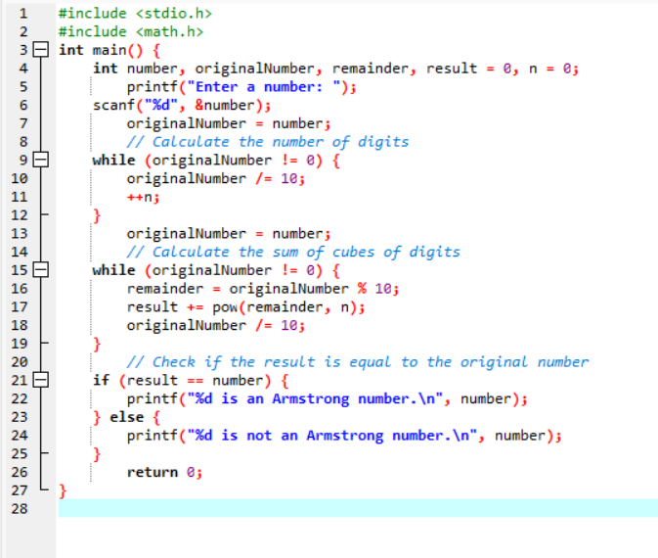

OTUPUT:

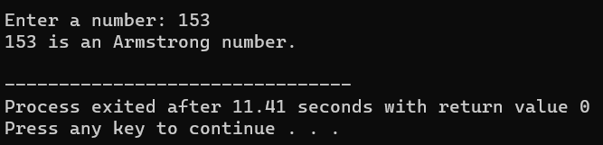

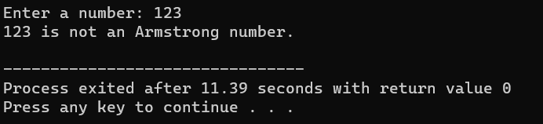

EXPERIMENT: 16

EXPERIMENT NAME: SUMMIMG UP ANY N NUMBERS AND FINDING AVERAGE

PROGRAM:

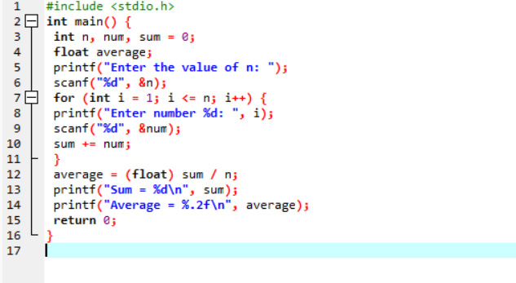

OUTPUT:

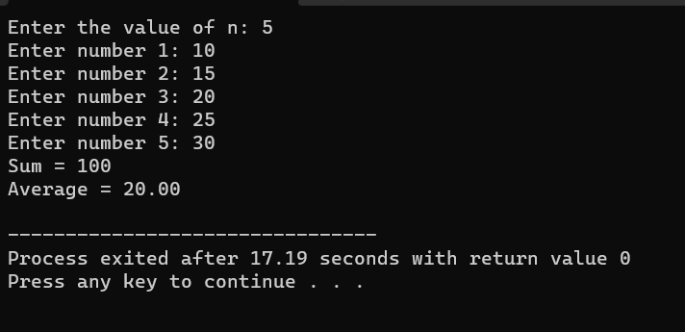

EXPERIMENT: 17

EXPERIMENT NAME: PRINTING DIGITS OF AN INTEGER NUMBER

PROGRAM:

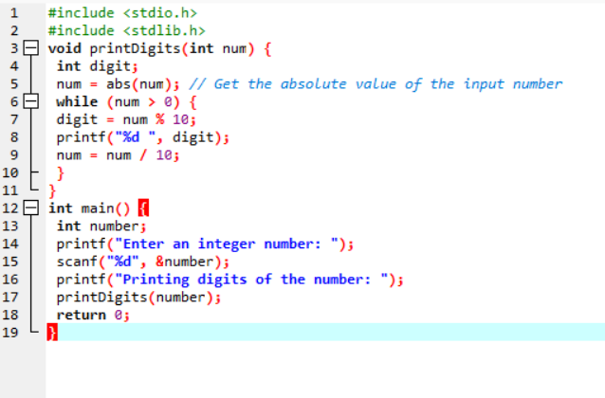

OUTPUT:

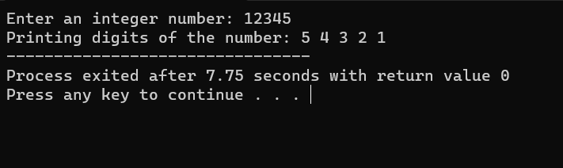

EXPERIMENT: 18

EXPERIMRNT NAME: SUMMING UP THE DIGITS OF AN INTEGER NUMBER

PROGRAM:

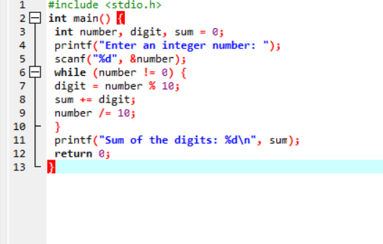

OUTPUT:

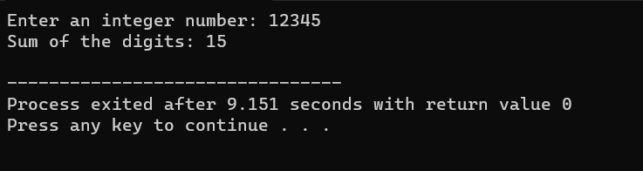

EXPERIMENT: 19

EXPERIMENT NAME: REVERSING THE DIGITS OF AN INTEGER NUMBER

PROGRAM:

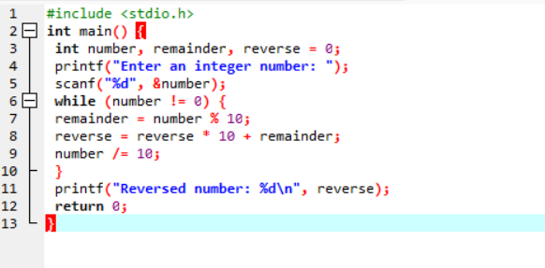

OUTPUT:

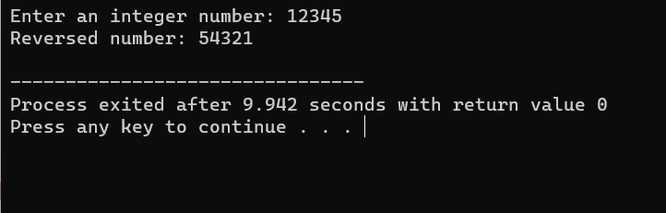

EXPERIMENT: 20

EXPERIMENT NAME: FINDING WHETHER THE GIVEN NUMBER INTEGER IS ODD OR EVEN

PROGRAM:

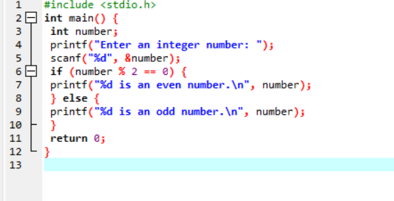

OUTPUT:

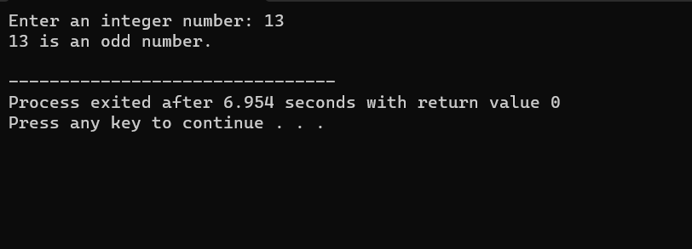

EXPERIMENT: 21

EXPERIMENT NAME:FINDING THE GIVEN INTEGER IS POSITIVE OR NEGATIVE

PROGRAM:

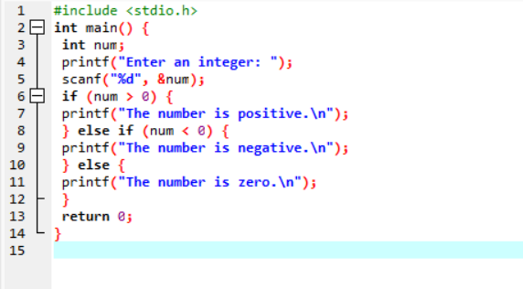

OUTPUT:

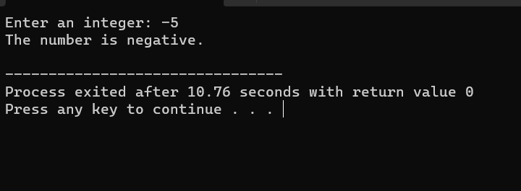

EXPERIMENT: 22

EXPERIMENT NAME:SWAPPING TWO NUMBERS WITH A TEMPORARY VARIABLE

PROGRAM:

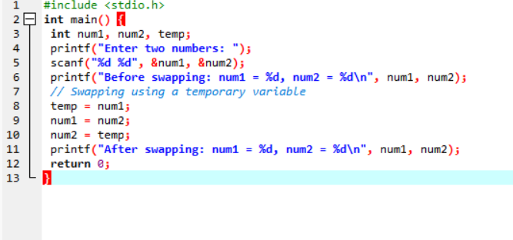

OUTPUT:

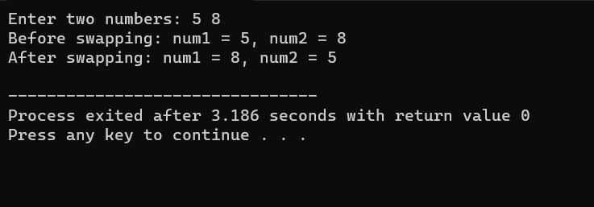

EXPERIMENT:23

EXPERIMENT NAME: SWAPPING TWO NUMBERS WITHOUT A TEMPORARY VARIABLE

PROGRAM:

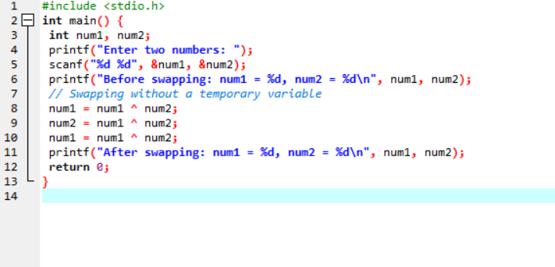

OUTPUT:

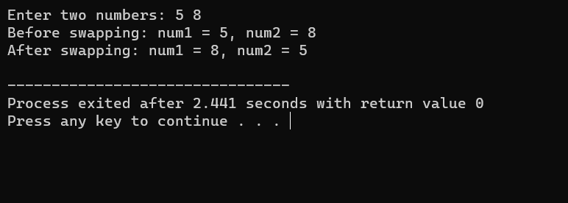

EXPERIMENT: 24

EXPERIMENT NAME: SWAP 3 NUMBERS A TO B,B TO C AND C TO A

PROGRAM:

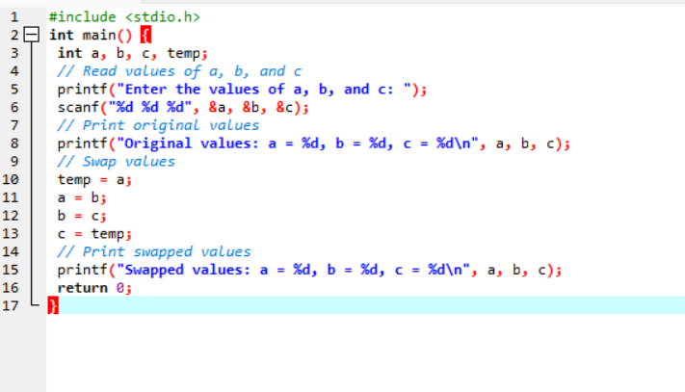

Output:

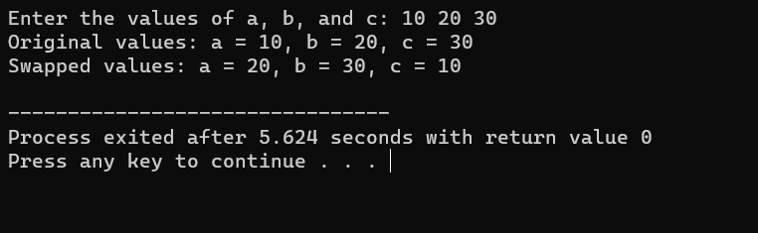

EXPERIMENT: 25

EXPERIMENT NAME: FINDING THE BIGGEST OUT OF 2 INTEGER NUMBER

PROGRAM:

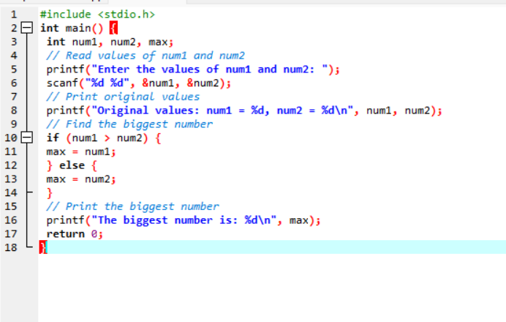

OUTPUT:

